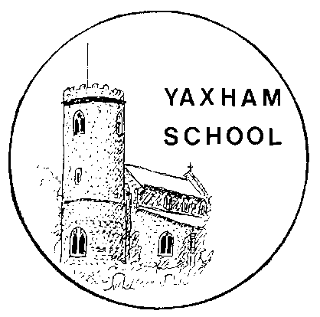
Yaxham Church of England (VA) Primary School
Clint Green, Yaxham, Dereham, Norfolk, NR19 1RU
Tel. 01362 692033
e-mail: office@yaxham.norfolk.sch.uk
www.yaxhamprimaryschool.co.uk
Headteacher: Mrs Jennie Müller
Chair of Governors: Mrs Michelle Parnell

Writing Expectations

This booklet gives an overview of what the expected standard for writing composition is in each year group, derived from the national curriculum. We hope this gives parents a concise picture of the content and progression for writing as children move through the school. The terminology contained in this document is used in school when teaching; the children are expected to know what technical terms mean, as these terms appear in the questions children have to answer in their end of key stage SATs. Most of the terminology should be clear due to the examples provided, however, I have provided a short glossary below for some of the terms that will perhaps be less familiar. Please speak to your child’s class teacher if you would like further information or guidance on any of the information in this booklet.

Mr S Moore
English Leader

Glossary
Phoneme - an individual sound, for example the sound made by the c in cat.
Grapheme - a single letter (e.g. the c in cat) or group of letters (e.g. the igh in sigh) that is used to represent a sound.
Segment - splitting up the word into its separate sounds, for example ‘bed’ as three sounds: b-e-d.
Clause - a part of a sentence. E.g. the sentence When it rains, I take an umbrella has two separate clauses.
Direct speech - speech punctuated by inverted commas (“Hello, how are you?”), as opposed to indirect or reported speech (He asked me how I was).
Conjunction - A word that links or joins two clauses. E.g. We couldn’t go out because it was raining.
Prepositions - show the relationship between the noun and the other things in the sentence, for example where (on, in, at, under, beside etc) or when (before, after, on Saturday etc) something is. E.g. In the holidays I get up early and get on my bike.
Fronted adverbial - a word or phrase at the beginning of a sentence, followed by a comma, which gives more information about what follows. E.g. At the strike of midnight, Cinderella’s dress turned into rags.
Parenthesis - extra information that can be removed without changing the meaning of the sentence. E.g James (who was 9 years old) loved going to school. Brackets, dashes or a pair of commas could all be used to indicate parenthesis in this sentence.
Relative clauses - Add information to sentences by using a relative pronoun such as who, that or which. E.g. That’s the singer who I was telling you about. The school, which has a large playing field, is located off the main road.

A reception writer…
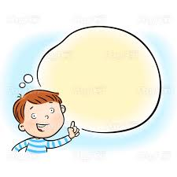
- Thinks and says what to write
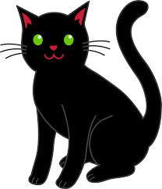
- Says the sounds in the word c...a….t
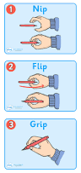
- Holds their pencil properly
- Puts a capital letter at the start A B C
- Writes the sounds in the word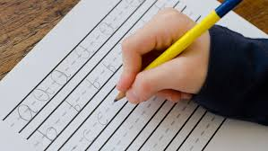
- Uses a sound card to help with sounds
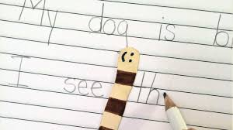
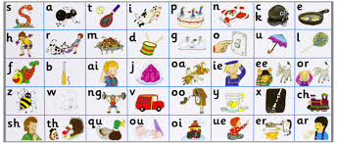
- Leaves a space before the next word
- Puts a full stop at the end.
- Reads back what they’ve written.
A year 1 writer …

Uses phonics skills to spell words
- They segment words to phonemes.
- They write a known grapheme for each phoneme.
- They use the letter name to say the spelling of a word.

Uses spelling rules.
- They add s or es to make plural nouns.
- They add the prefix un to change the meaning of a word.
- They add suffixes –ing, -ed, -er, and –est to change words.
- They learn the spellings of some common exception words.

Uses sentences.
- They compose their sentence orally before writing it.
- They join words and clauses using and to make sentences.
- They write sentences that make sense to the reader.
- They sequence sentences to make short stories.
- They reread what they have written to check it make sense.

Uses a range of punctuation correctly.
- They use a capital letter to begin a sentence.
- They use a full stop to end a sentence.
- They leave a finger space between words.
- They use a capital letter for a name and personal pronoun I.
- They use a question mark to end a questioning sentence.
- They use an exclamation mark to end an exclaiming sentence.

A year 2 writer….
Uses the correct punctuation.
- They use full stops correctly.
- They use a capital letter at the start of a sentence or for proper nouns.
- They use ! and ? correctly in their writing.
- They use an apostrophe to show that someone owns something e.g. Sophie’s doll

Uses interesting words and phrases.
- They can use statements, commands, questions and exclamations.
- They can use conjunctions and extend sentences.
And or but because so also

Spells lots of words correctly.
- They spell common words correctly.
- They can spell more common exception words.
- They correctly add suffixes to their words.
e.g. –ment -ness -full -less -ly
- They can add prefixes to their words correctly.
e.g. Un- re- dis-
- They can write the contracted forms.
e.g. I’ve can’t won’t he’ll we’re

Forms their letter correctly.
- They make their letters the same size and shape.
- They leave a finger space between each word.
- They are beginning to join their letters.

A year 3 writer…
Uses a full range of punctuation correctly.
- They know how to use capital letters, full stops, ! and ? correctly
- They use apostrophes accurately to show possession or to show contractions.
- They use commas within lists and to separate clauses.
- They use inverted commas to punctuate direct speech.

Uses interesting words and sentences.
- They make ambitious word choices to add interest and detail.
- They write sentences with more than one clause using a wide range of conjunctions.
- Use conjunctions, adverbs and prepositions to express time, cause and place.

Organises their writing to make it clear for their audience.
- They compose and rehearse sentences orally.
- They use paragraphs to group ideas and information.
- They use headings, subheadings, diagrams and captions as appropriate in their non-fiction writing.

Writes exciting stories that they plan out.
- They describe the setting and atmosphere using descriptive language.
- They introduce the characters.
- They plan a good plot with a beginning that sets the scene, an interesting problem in the middle for the character to solve and resolutions that ends the story.

Edits their work.
- They proof-read for spelling and punctuation errors.
- They improve their grammar and vocabulary choices.
Has a high standard of presentation.
- They have handwriting which is joined, and legible.
A year 4 writer …
Uses a full range of punctuation correctly.
- They use apostrophes for plural possession.
- They use a comma after a fronted adverbial.
- They use commas to separate clauses.
- They use inverted commas and other punctuation to punctuate direct speech.
Uses interesting words and sentences.
- They vary sentence structure using different openers.
- They write sentences with more than one clause using a wide range of conjunctions.
- They choose nouns or pronouns appropriately to avoid repetition.
- They use fronted adverbials.
- Use conjunctions, adverbs and prepositions to express time and cause.
- They make ambitious word choices to add interest and detail.
Organises their writing to make it clear for their audience.
- They compose and rehearse sentences orally.
- They use paragraphs to organise ideas around a theme.
- They create settings, characters and plots in narratives.
- They use headings, subheadings and captions in non-fiction writing.
Edits their work.
- They proof-read for spelling and punctuation errors.
- They improve their grammar and vocabulary choices.
Has a high standard of presentation.
- They have handwriting which is joined, legible and consistent.
- They know how and when to join adjacent letters.

A year 5 writer …
Uses a full range of punctuation correctly.
- They use apostrophes for plural possession.
- They use a comma after a fronted adverbial or to separate clauses.
- They use inverted commas and other punctuation to punctuate direct speech.
- They use brackets, dashes or commas to indicate parenthesis.
Uses a wide vocabulary and varied sentence structures.
- They write extended sentences with more than one clause using a wide range of conjunctions.
- They vary sentence structure by using different openers including fronted adverbials.
- They use exciting vocabulary choices.
- They use relative clauses and punctuate them with commas.
- They use adverbs and modal verbs to indicate degrees of possibility.
- They can use suffixes and prefixes correctly to alter the meaning of words.
- They can spell many words correctly from the Year 5 / 6 spelling list.
Organises their writing to make it clear for their audience.
- They use paragraphs to organise their ideas and make links between them.
- They can choose an appropriate style of writing depending on the purpose.
- They can reveal characters and settings through dialogue and narrative.
- They can use features such as headings, subheadings and bullet points in non-fiction writing.
Edits their work.
- They proof-read for spelling and punctuation errors.
- They make choices to improve their sentence-structures or vocabulary.
Has a high standard of presentation.
- They have a neat and consistent style of joined handwriting.

A year 6 writer…
Uses a full range of punctuation correctly.
- They use apostrophes for possession or contraction.
- They use a comma to clarify meaning.
- They use inverted commas and other punctuation for direct speech.
- The use brackets, dashes or commas to indicate parenthesis.
- They can sometimes use semi-colons, colons or dashes effectively between clauses.
- They can sometimes use hyphens to avoid ambiguity.
Uses a wide vocabulary and varied sentence structures.
- They vary their vocabulary choices according to the level of formality required.
- They write extended sentences with a range of clause structures.
- They use adverbs and modal verbs to indicate degrees of possibility.
- They add detail and precision by using adverbs, prepositions phrases and expanded noun phrases effectively.
- They can use suffixes and prefixes correctly from the Year 5 /6 spelling list.
Writes effectively for their audience.
- They can identify their audience and select an appropriate form.
- They can create atmosphere in their writing.
- They use description and integrating dialogue to convey character and advance the action.
- They use paragraphs to organise their ideas and make cohesive links within and between them.
- In non-narrative texts, they can use a range of features such as headings, subheadings, bullet points or underlining to organise their writing.
Edits their work.
- They proof-read for spelling and punctuation errors.
- They make changes to improve their sentence structures or vocabulary.
- They check for consistency of tenses.
Has a high standard of presentation.
- They have a neat and consistent style of joined handwriting.

